Sardar Patel Institute of Technology, Mumbai

**Department of Computer Science Engineering**

**B.E. Sem-VII-PE-IV (2024-2025)**

**IT 24 - AI in Healthcare**

**Experiment 10: Healthcare data analysis using Power BI**

# Name: Adwait Purao UID: 2021300101 Date: 17/11/24

**Objective:** To implement Power BI in a Healthcare dataset to analyze Key Performance Indicators (KPI) to create a dashboard.

# Theory:

## Clinical KPIs

**What They Measure:**

Clinical KPIs focus on the quality of patient care and clinical outcomes. These indicators are tied directly to patient health, the effectiveness of treatments, and the safety of care delivery.

## Examples of Clinical KPIs:

* **Mortality Rates**: The rate of patient deaths in a hospital or clinic, often adjusted for patient risk factors.
* **Readmission Rates**: The frequency at which patients are readmitted within 30 days of discharge, which can indicate issues with initial care or discharge planning.
* **Infection Rates**: Monitoring hospital-acquired infections (HAIs), such as MRSA or sepsis.
* **Medication Errors**: The number of medication-related incidents or mistakes made during patient treatment.

## Impact on Decision-Making:

* **Improvement of Care Protocols:** Clinical KPIs help healthcare leaders identify areas

where care delivery can be improved. For example, if infection rates are high, the hospital may invest in better hygiene practices, more training, or updated protocols for surgery or patient care.

* **Resource Allocation:** Clinical KPIs guide where resources (staff, equipment, and training) are needed most. A high readmission rate, for instance, might lead to the implementation of a more robust follow-up system or better patient education before discharge.
* **Regulatory Compliance and Accreditation:** Many clinical KPIs are tied to accreditation standards, such as those from The Joint Commission or CMS. Poor performance in these KPIs can result in penalties or reduced funding, influencing organizational strategy.

## Operational KPIs What They Measure:

Operational KPIs focus on the efficiency and productivity of healthcare facilities. These include how well resources are being utilized, whether processes are running smoothly, and how well staff is performing.

## Examples of Operational KPIs:

* **Patient Flow Efficiency**: Time taken for patients to move through different stages of care (e.g., from emergency admission to discharge).
* **Bed Occupancy Rates**: Percentage of available beds being occupied, indicating hospital capacity and demand.
* **Staff Utilization Rates**: The number of patients per nurse, or the hours worked relative to workload, which can indicate potential overwork or inefficiencies.
* **Wait Times**: How long patients wait before receiving care, whether in the emergency room or for scheduled appointments.

## Impact on Decision-Making:

* **Optimizing Resource Utilization:** Operational KPIs highlight inefficiencies or areas where resources are underutilized. For example, if bed occupancy is consistently high,

hospital administrators might decide to expand facilities, hire more staff, or implement a more efficient patient scheduling system.

* **Cost Control:** Operational KPIs are critical for controlling operational costs. For instance, high wait times or inefficient patient flow could result in lost revenue or patient dissatisfaction, prompting decisions to streamline processes or introduce new technologies (e.g., electronic health record (EHR) systems).
* **Staffing Decisions:** A nurse or physician’s workload is a key operational indicator.

Poor staff utilization (e.g., underworked or overworked personnel) may lead to

decisions around staffing levels, shift scheduling, or the hiring of temporary workers.

## Patient Satisfaction KPIs What They Measure:

These KPIs focus on the experience of patients in the healthcare system, including communication with providers, the comfort and cleanliness of the facility, and the perceived quality of care.

## Examples of Patient Satisfaction KPIs:

* **Patient Satisfaction Scores (e.g., HCAHPS - Hospital Consumer Assessment of Healthcare Providers and Systems)**: This survey measures patient experience in several domains, such as communication with doctors and nurses, responsiveness of hospital staff, and cleanliness of the hospital environment.
* **Net Promoter Score (NPS)**: A measure of how likely patients are to recommend the healthcare facility to others.
* **Patient Complaints and Grievances**: Frequency of formal complaints, which may indicate systemic issues in care delivery.
* **Patient Wait Times for Services**: Length of time patients wait for scheduled appointments or procedures.

## Impact on Decision-Making:

* **Improving Patient-Centered Care:** Low patient satisfaction scores can trigger improvements in patient-provider communication or facility amenities. For

example, if patients report dissatisfaction with wait times or the cleanliness of the hospital, leadership may invest in more staff, better cleaning protocols, or process reengineering to shorten wait times.

* **Retention and Reputation Management:** Poor patient satisfaction can directly impact patient retention and reputation. A hospital that receives frequent complaints may

struggle with patient loyalty, affecting its market share. Decisions regarding PR campaigns, patient loyalty programs, or improvements to the physical environment (e.g., updated waiting areas) could be driven by these KPIs.

* **Patient Safety and Outcomes:** A poor patient experience (as reflected in KPIs like dissatisfaction with care or long wait times) can indirectly signal issues in clinical care. Healthcare organizations may take corrective actions, such as staff training or facility upgrades, to enhance overall patient safety and treatment outcomes.

## Importance of KPIs in Healthcare Management

KPIs in healthcare management are essential because they provide measurable data that can directly influence organizational decisions at every level. Their importance is multifaceted:

* **Data-Driven Decision Making:** KPIs allow leaders to make informed decisions based on objective, quantifiable data rather than subjective opinion. This reduces uncertainty and

leads to more consistent and effective management practices.

* **Performance Monitoring and Accountability:** KPIs hold individuals, teams, and entire healthcare organizations accountable. They create a framework for assessing performance and identifying areas for improvement, helping to ensure that goals are met and quality

standards are maintained.

* **Strategic Goal Setting and Benchmarking:** Healthcare organizations can use KPIs to set clear goals and benchmarks, aligning operational and clinical strategies with desired outcomes. For example, if an organization’s goal is to reduce readmission rates, tracking this KPI regularly ensures that initiatives like discharge planning or follow-up care are effective.
* **Cost Reduction and Efficiency:** By tracking operational KPIs, healthcare

organizations can identify inefficiencies that result in unnecessary costs (e.g., long patient stays, delayed surgeries, underutilized resources). Addressing these

inefficiencies through targeted interventions can significantly improve the financial health of the institution.

* **Quality Improvement:** Regular monitoring of clinical and patient satisfaction KPIs enables continuous quality improvement. By consistently evaluating these indicators, healthcare leaders can prioritize initiatives that improve patient outcomes, staff performance, and the overall patient experience.

**Output:**

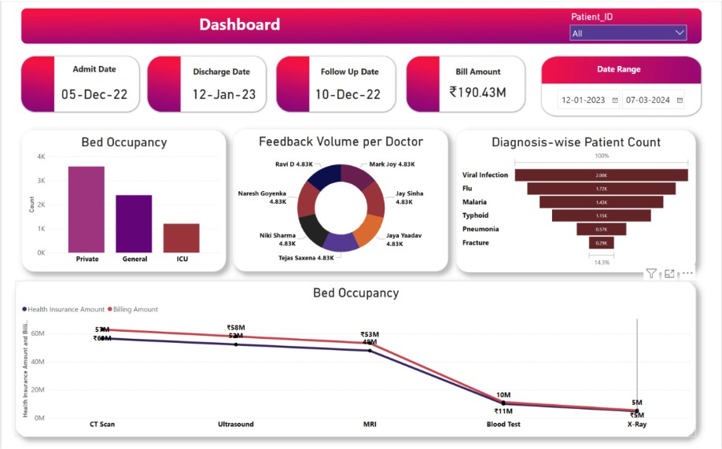

**CONCLUSION:**

Key performance indicators (KPIs) play a crucial role in healthcare management, offering valuable insights into clinical care, operational efficiency, and patient experience. By providing a detailed, data-driven view of performance, KPIs help organizations enhance care quality, optimize operations, lower costs, and improve patient satisfaction. Utilizing KPIs effectively enables healthcare managers to pinpoint areas for improvement and make strategic decisions that drive better patient outcomes, greater operational efficiency, and stronger financial performance.